# Informatica PowerCenter Installation files extraction – Version 11.1.1.7.0 for Microsoft Windows x64 (64-bit)https://edelivery.oracle.com/osdc/adf/images/t.gif

* Once we download all the files from Oracle e delivery cloud , we will get a set of zip files on our local system as shown in below screenshot.

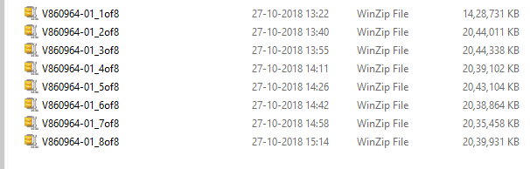

* The next step would be unzipping all these files one by one to get the installer file and zip partitions.

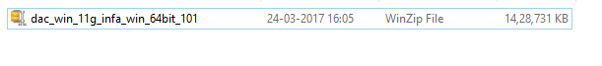



* There would be six more files partitioned zip files extracted from previous step.
* The next step would be unzipping the files as shown below

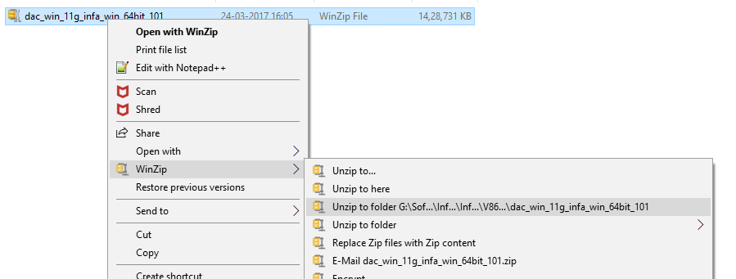

* The process will ask for the remaining partitioned zip files to be selected to complete the unzip process.
* It’s a sequential unzipping of the archives to build one set of installer files.
* If the extraction process is successful we would be seeing below set of files.

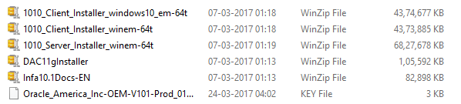

THANK YOU